OLIVIA WILSON
F a s h i o n D e s i g n e r

Let me introduce myself, I am a fashion designer who has 7 years of experience in this job. I am very experienced in various fashion styles for all seasons and I have made various models for men and women for a world famous brand.

 EXPERIENCE
 EDUCATION

Salford Company 2020 - 2022

Fashion Manager
Fashion School Aldenaire University
2020 - 2022

Already made all the styles for all seasons and made all the designs to be more sold.
Salford Company 2020 - 2022
Already made all the styles for all seasons and made all the designs to be more sold.
Fashion School 2020 - 2022

Aldenaire University

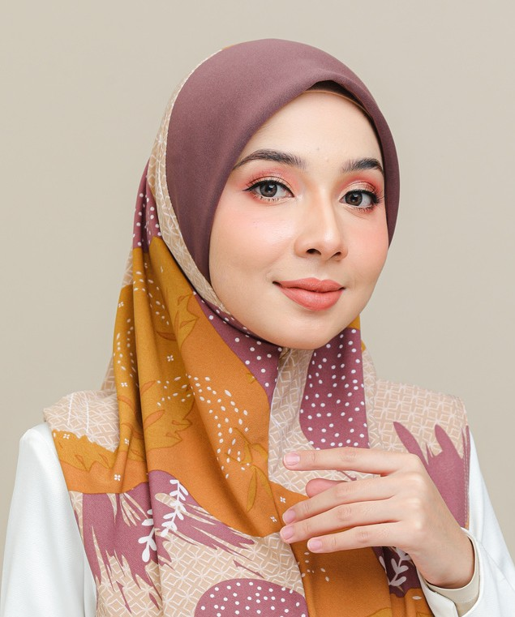Fashion Manager
Already made all the styles for all seasons and made all the designs to be more sold.

Salford Company 2020 - 2022

Fashion Manager
Already made all the styles for all seasons and made all the designs to be more sold.
Already made all the styles for all seasons and made all the designs to be more sold.

 CONTACT

 +123-456-7890
 hello@reallygreatsite.com  www.reallygreatsite.com 123 Anywhere St., Any
City, ST 12345

